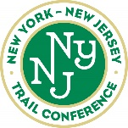
Standard paint colors

Standard paint colors recommended for general use on 2x3 blazes; Revised from the Trail Maintenance Manual (7th Edition) p24-25 Approved by Trails Council, February 13, 2008

DISCLAIMER: The colors represented either on screen or on your printer may not represent what they will look like on a tree)

It is more important that the color used on a single trail be uniform than that you exactly match one of these colors. If you don't know exactly what paint was used, repaint all the blazes. The colors change significantly upon drying so don't compare wet with dry.

- All the Standards and Alternates should be available in one quart cans.
- Alternates are based on closest match and readily available colors.
- Gloss is preferred for longevity.
- Spray cans are preferred in matte finish.
- Color samples obtained online and may not be true.
- Neutralizing or Block-out colors are suggestions only. Your choice will depend on the species and age of the trees or rock color. Some trees, such as, Chestnut Oak will require a darker charcoal gray color.

COLOR | TC STANDARD | ALTERNATES
WHITE | H-D/Behr 1850  Ultra Pure White | Or Any  True White
BLUE | Ben.Moore 0789  Sea to Shining Sea | Sher. Williams  SW6953  Candid Blue | H-D/Behr  530B-4  Bliss Blue | Lowes/Valspar  5002-9C  Summer Splash
 |  |  | 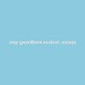 | 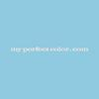
BLUE on  WHITE | Ben.Moore 0784  Blue Macaw | Sher.Williams  SW6796  Blue Plate | H-D/Behr  520B-7  Havasu | Lowes/Olympic  B51-5  Planetarium
 | 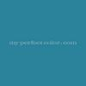 | 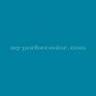 | 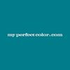 | 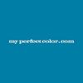

COLOR | TC STANDARD |  | ALTERNATES
GREEN | Ben.Moore 0558  Killala Green |  | H-D/Glidden  34GY40/515  Topiary Green |  | H-D/Behr  S-G-420  Limeade |  | Lowes/Valspar  6005-10B  Jaunty Green
 |  |  | 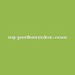 |  | 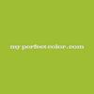 |  | 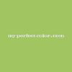
ORANGE | Ben.Moore2014-20  Rumba Orange  (Safety) |  | H-D/Glidden  68YR28/701  Fiesta Orange |  | H-D/Behr  210B-7  Flame |  | Lowes/Valspar  2002-1A  Autumn Blaze
 | 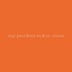 |  | 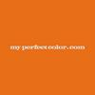 |  | 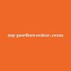 |  | 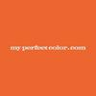
RED | Ben. Moore  2000-10  Red (Safety) |  | Sher.Williams  SW4081  Safety Red |  | H-D/Behr8371  Candy Apple Red |  | Lowes/Valspar  1009-2  Classic Red
 | 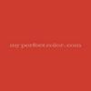 |  | 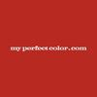 |  |  |  | 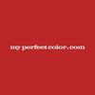
YELLOW | Ben. Moore 2022-20  Sun Kissed Yellow (Safety) |  | Sher.Williams  SW6906  Citrus |  | H-D/Behr  330B-7  Sunflower |  | Lowes/Valspar  3005-1A  Golden Delight
 |  |  |  |  | 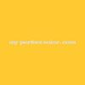
PINK | Ben. Moore  2079-50  Rhododendron |  | Sher.Williams  SW6849  Party time |  | H-D/Behr  680A-3  Pink Bliss |  | Lowes/Valspar  1001-2A  Magic Wand
COLOR |  | TC STANDARD |  | ALTERNATES
LONG PATH |  | PPG 103-4 Tropical Tide (former Parakeet Aqua) |  | H-D/Behr 470B-4 Intense Jade |  | Lowes/Valspar  6002-10A  Lavish Green
 |  |  |  | 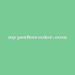 |  | 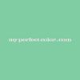
HIGHLANDS  TRAIL |  | Dutch Boy10F-5  (11-B-5) Lake Superior |  | H-D/Behr  490B-5  Cozumel |  | Lowes/Valspar  5006-10B  Turquoise Tint
 |  |  |  | 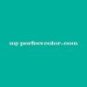 |  | 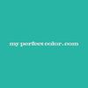

NEUTRALIZING | TC STANDARD | ALTERNATES
DARK | Ben.Moore 1491  Aegean Olive | SPRAYCAN  Rustoleum  7713 Dark Bronze  1918, Earth Brown,  Krylon 4292Brown | H-D/Behr 780D-7  Wild Rice | H-D/Behr 420F-7  Forest Ridge
 | 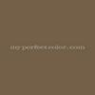 |  | 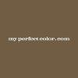 | 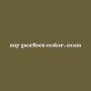
MEDIUM | Ben. Moore  2139-30 Sharkskin | SPRAY CAN  Rustoleum  7754 Anodized Bronze  7739 Charcoal Green;  Krylon 4293  Olive | H-D/Behr 790D-6  Dusty Mountain | H-D/Behr 720F-4  Stone Fence
 |  |  |  | 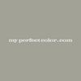
LIGHT | H-D/Behr  770E-3  Pewter Mug | SPRAY CAN  For Gray:  (& for rocks)  Rustoleum  (Amer. Acc.)  243265  Granite | SPRAYCAN  For Beige: Rustoleum 1970 - Khaki | H-D/Behr  790E-2  Gentle Rain
 |  |  | 